Test Case: tc001_SPX_Dev5_Crear_Nueva_Linea_Requisicion_Spot_Tipo_Cobro_CC
Step 1 - Enter username and password and click to button Enter : Credentials Entered
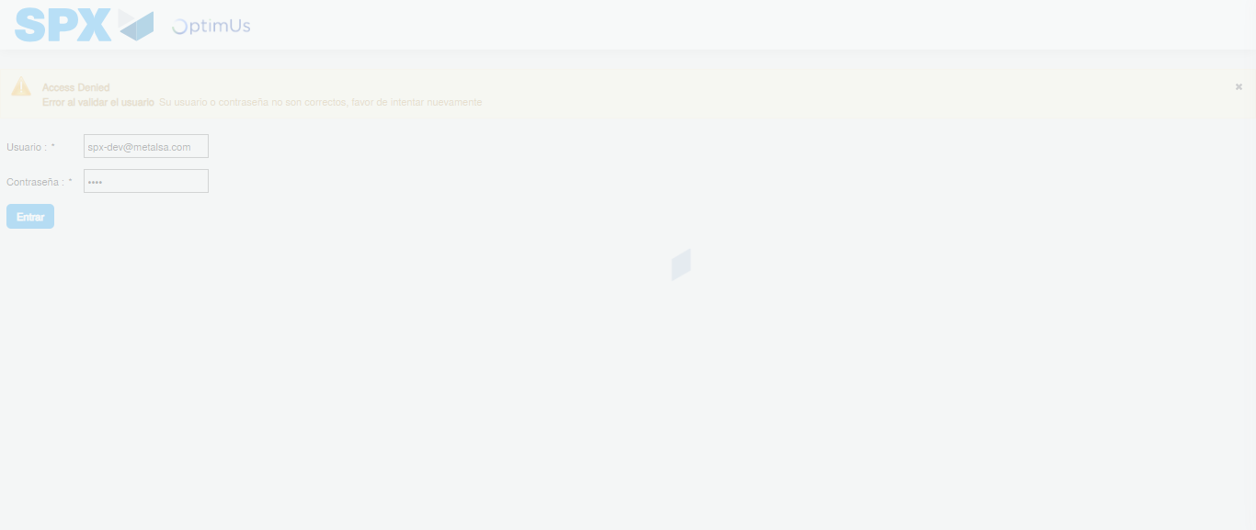Image file-name: QC_Testing-tc001_SPX_Dev5_Crear_Nueva_Linea_Requisicion_Spot_Tipo_Cobro_CC-1790176082462

Step 2 - Select to UEN and Access to Spot Buy Requisitions : UEN Correctly selected and Correct access
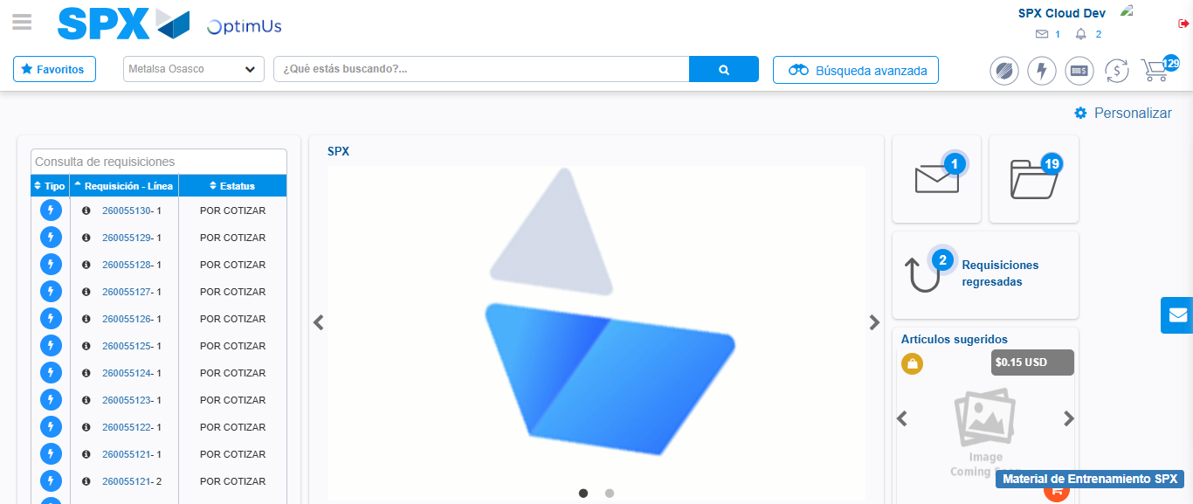Image file-name: QC_Testing-tc001_SPX_Dev5_Crear_Nueva_Linea_Requisicion_Spot_Tipo_Cobro_CC-1790176107073

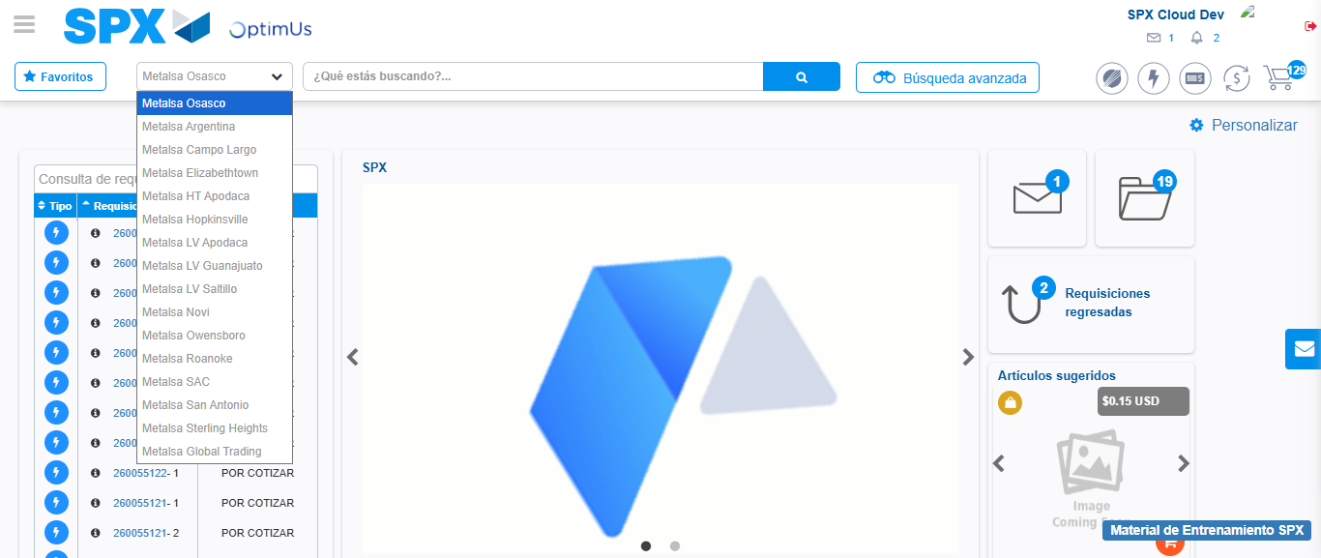Image file-name: QC_Testing-tc001_SPX_Dev5_Crear_Nueva_Linea_Requisicion_Spot_Tipo_Cobro_CC-1790176107646

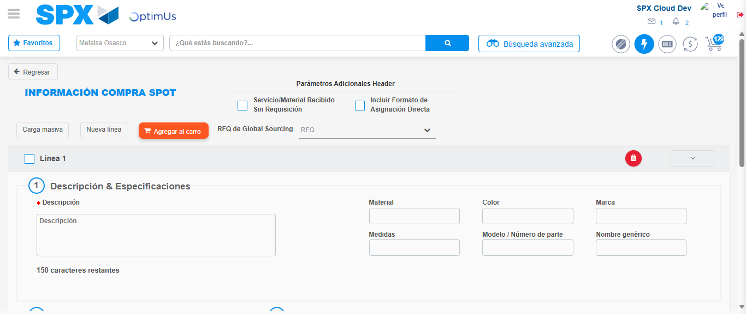Image file-name: QC_Testing-tc001_SPX_Dev5_Crear_Nueva_Linea_Requisicion_Spot_Tipo_Cobro_CC-1790176111991

Step 3 - Data Capture Spot Buy Requisition: Data captured correctly
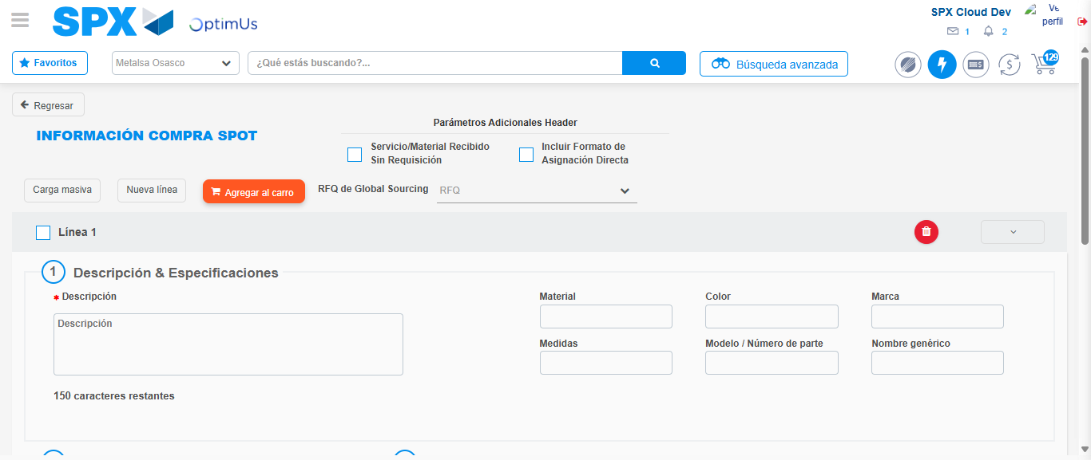Image file-name: QC_Testing-tc001_SPX_Dev5_Crear_Nueva_Linea_Requisicion_Spot_Tipo_Cobro_CC-1790176112264

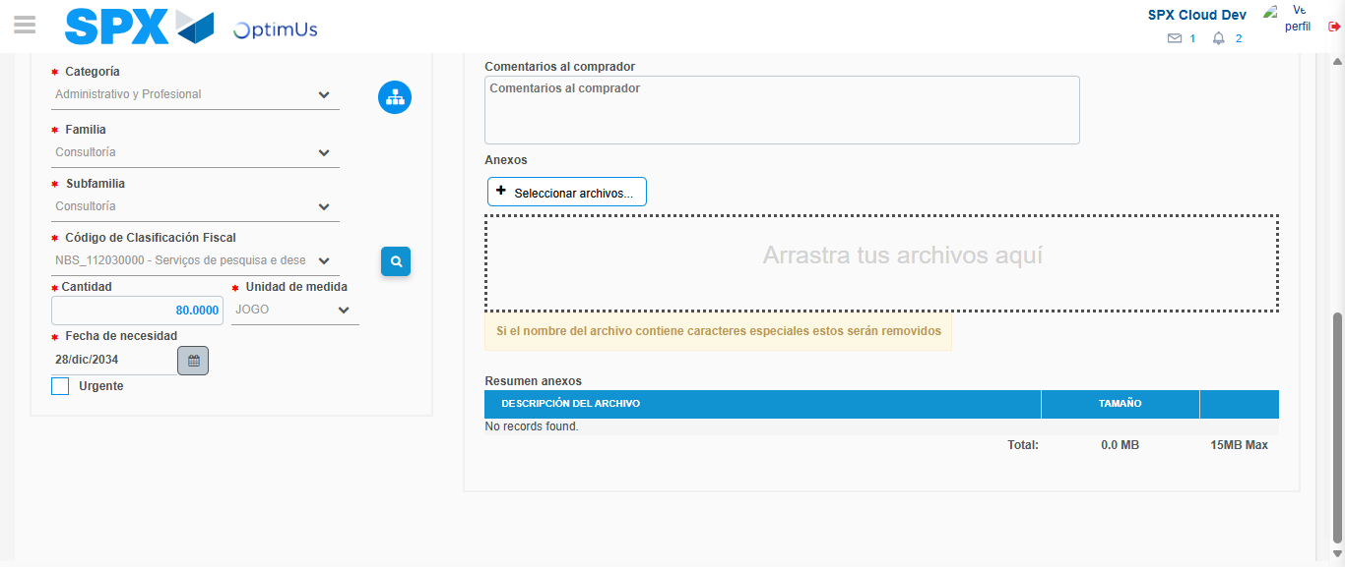Image file-name: QC_Testing-tc001_SPX_Dev5_Crear_Nueva_Linea_Requisicion_Spot_Tipo_Cobro_CC-1790176128332

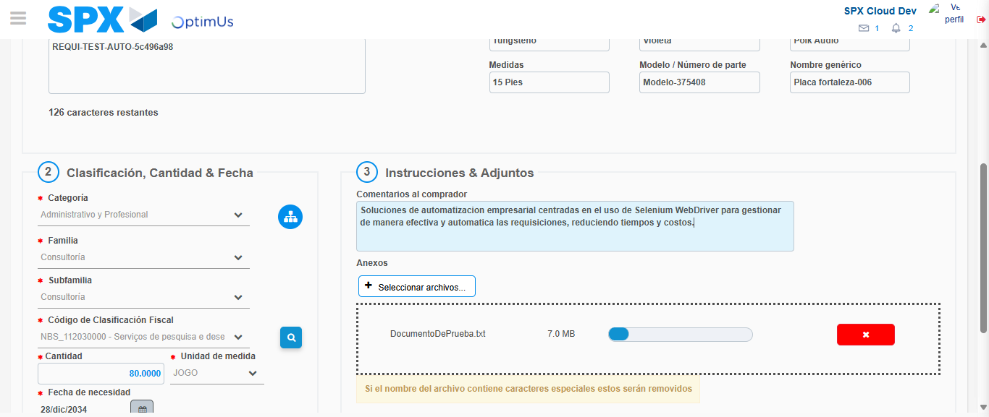Image file-name: QC_Testing-tc001_SPX_Dev5_Crear_Nueva_Linea_Requisicion_Spot_Tipo_Cobro_CC-1790176129098

Step 4 - Add new line and data capture second line: Line add correctly
Image file-name: QC_Testing-tc001_SPX_Dev5_Crear_Nueva_Linea_Requisicion_Spot_Tipo_Cobro_CC-1790176112264

Image file-name: QC_Testing-tc001_SPX_Dev5_Crear_Nueva_Linea_Requisicion_Spot_Tipo_Cobro_CC-1790176128332

Image file-name: QC_Testing-tc001_SPX_Dev5_Crear_Nueva_Linea_Requisicion_Spot_Tipo_Cobro_CC-1790176129098

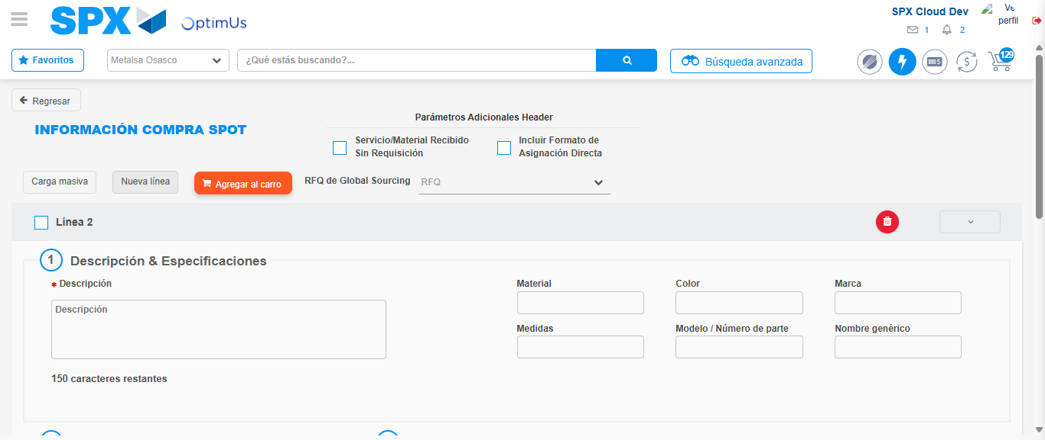Image file-name: QC_Testing-tc001_SPX_Dev5_Crear_Nueva_Linea_Requisicion_Spot_Tipo_Cobro_CC-1790176131354

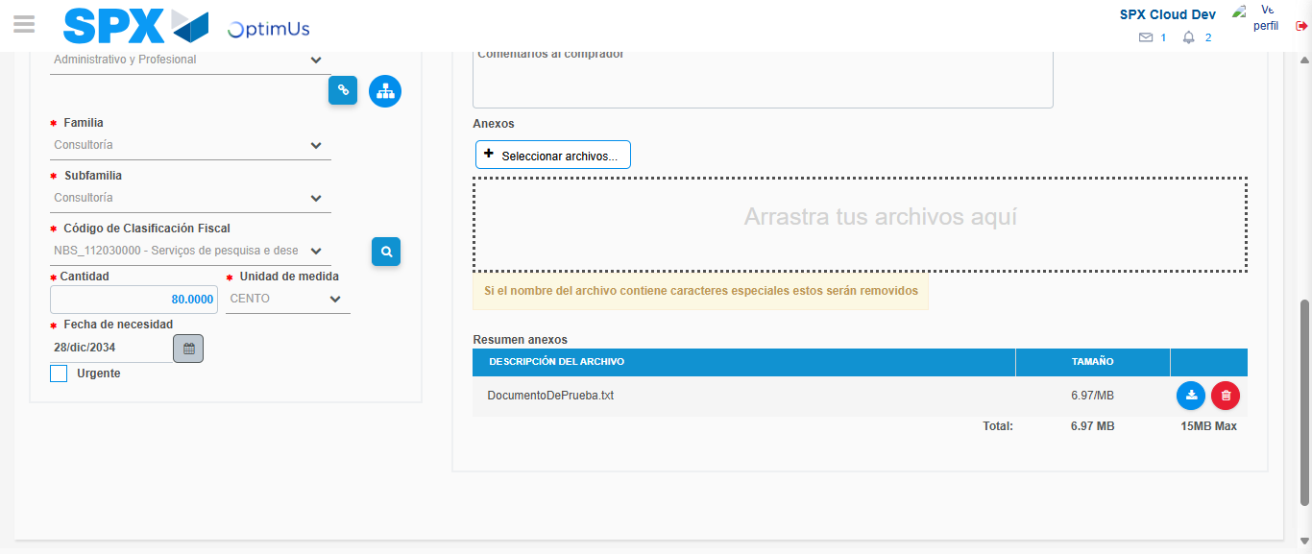Image file-name: QC_Testing-tc001_SPX_Dev5_Crear_Nueva_Linea_Requisicion_Spot_Tipo_Cobro_CC-1790176147055

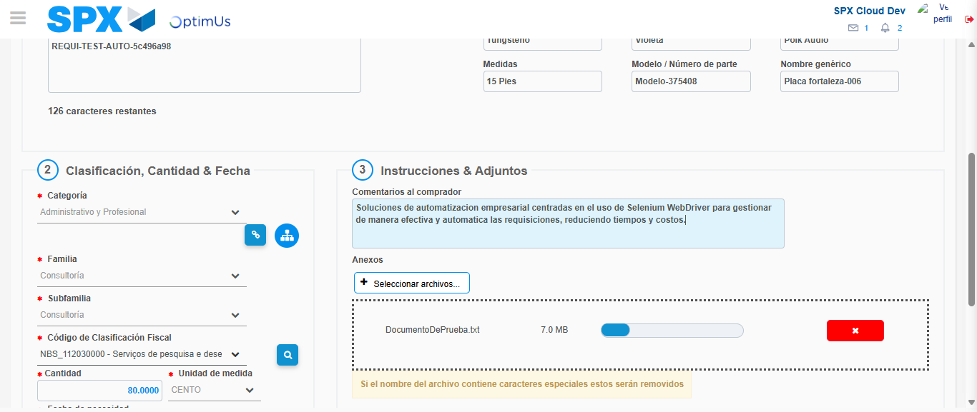Image file-name: QC_Testing-tc001_SPX_Dev5_Crear_Nueva_Linea_Requisicion_Spot_Tipo_Cobro_CC-1790176147825

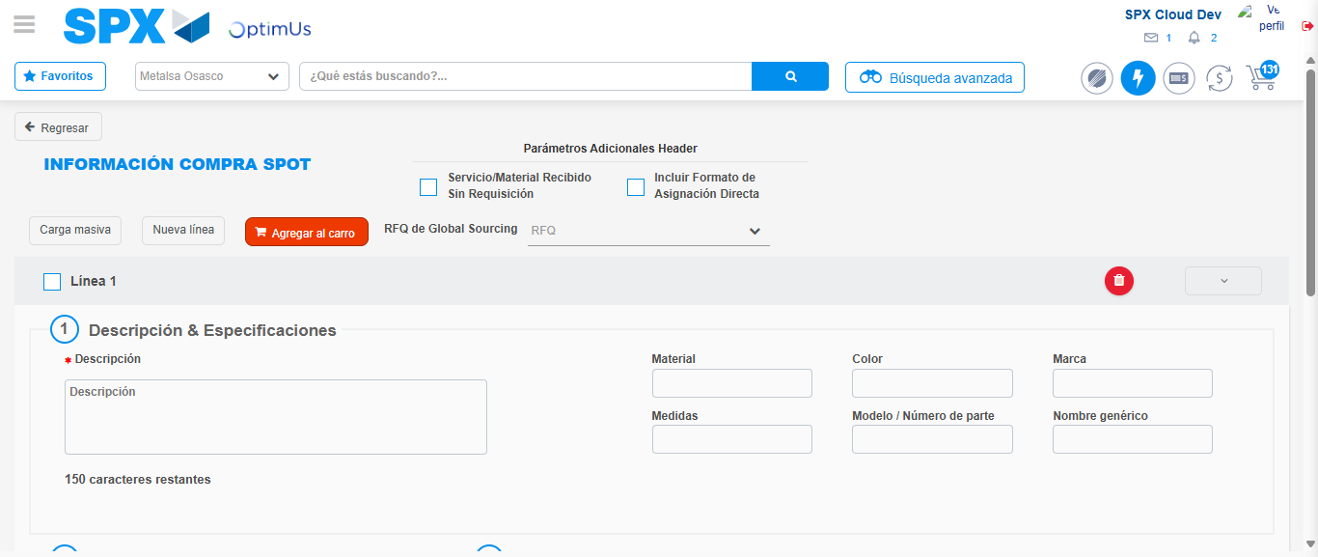Image file-name: QC_Testing-tc001_SPX_Dev5_Crear_Nueva_Linea_Requisicion_Spot_Tipo_Cobro_CC-1790176163970

Step 8 - Return to Main Page SPX : Return to Main Page SPX
Image file-name: QC_Testing-tc001_SPX_Dev5_Crear_Nueva_Linea_Requisicion_Spot_Tipo_Cobro_CC-1790176107073

Image file-name: QC_Testing-tc001_SPX_Dev5_Crear_Nueva_Linea_Requisicion_Spot_Tipo_Cobro_CC-1790176107646

Image file-name: QC_Testing-tc001_SPX_Dev5_Crear_Nueva_Linea_Requisicion_Spot_Tipo_Cobro_CC-1790176111991

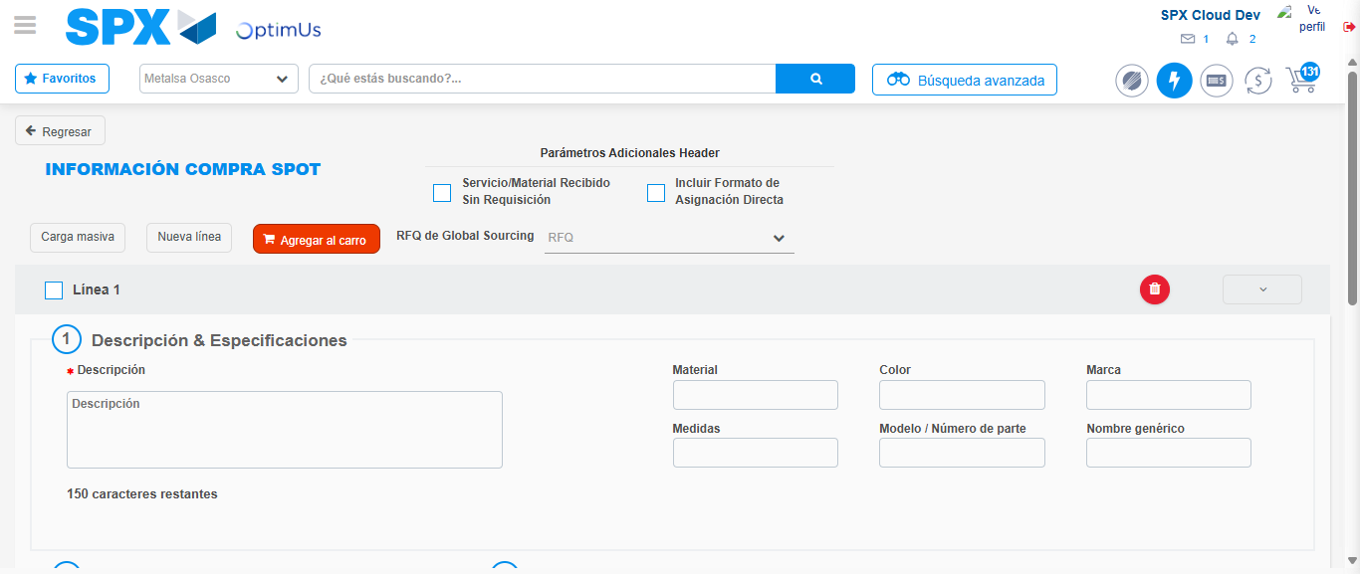Image file-name: QC_Testing-tc001_SPX_Dev5_Crear_Nueva_Linea_Requisicion_Spot_Tipo_Cobro_CC-1790176166174

Image file-name: QC_Testing-tc001_SPX_Dev5_Crear_Nueva_Linea_Requisicion_Spot_Tipo_Cobro_CC-1790176166351

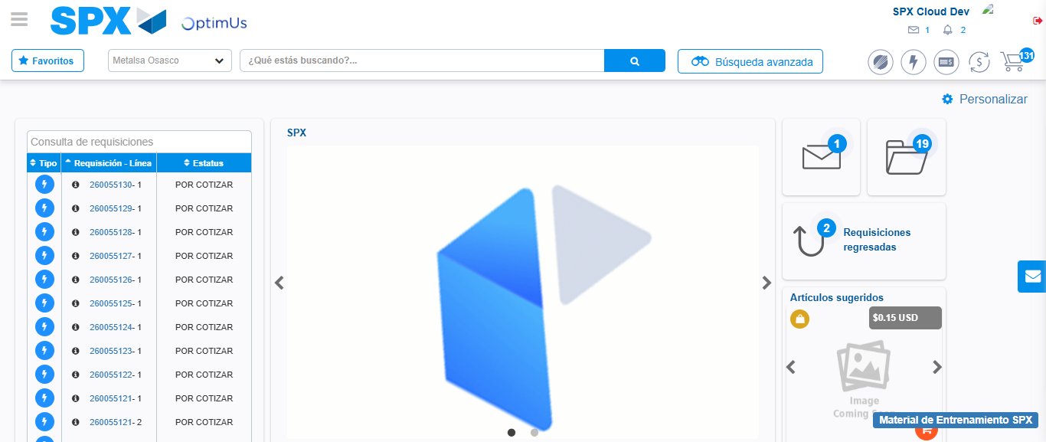Image file-name: QC_Testing-tc001_SPX_Dev5_Crear_Nueva_Linea_Requisicion_Spot_Tipo_Cobro_CC-1790176187529

Step 9 - Log Out : Log Out SPX
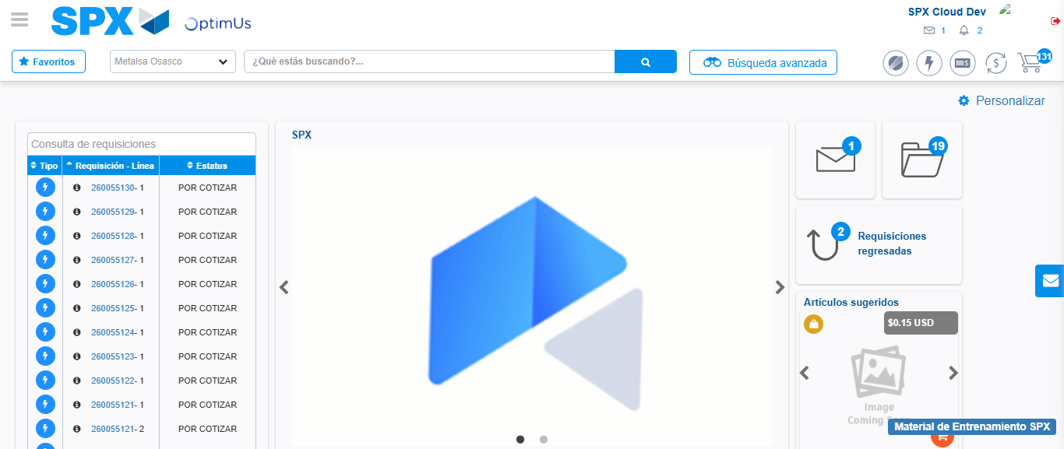Image file-name: QC_Testing-tc001_SPX_Dev5_Crear_Nueva_Linea_Requisicion_Spot_Tipo_Cobro_CC-1790176187914

